Invitational Report: Mark Rosewater
Mark Rosewater
Mark with champion Jon Finkel
I had planned to post this report after I had posted the sixteen player reports. As the reports slowly dragged in, I kept reworking my coverage (adding whole new sections). When the fifteenth report finally came in (from Noah Boeken), I decided it was time to wrap it up and finally post this report. So, here is my long-awaited (well, at least long-winded) tournament report:
While thinking about what to write this year, it dawned on me that I had the opportunity to write a very distinctive tournament report. Almost all tournament reports are from the perspective of the players in the tournament. When a computer malfunctions, we simply hear about how the players had to wait half an hour. We never hear about what went wrong with the computer or how long the organizer was able to hide the problem from the players. This year I'm going to give you all an inside look at the behind the scenes of running the Magic Invitational.
One warning: This tournament report is long. Very long. I'm talking Gary Wise long. So long in fact, that it will be appearing in two parts. Buckle up.

The Location
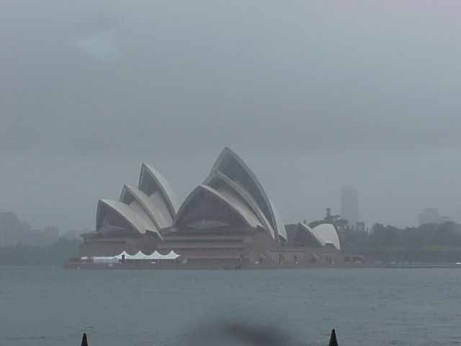
The very first decision made every year for the Magic Invitational is where to hold it. From Hong Kong to Rio de Janeiro to Barcelona to Kuala Lumpur, we have always tried to make it an exotic locale that the top players have never visited. Also, we always hold the Invitational in conjunction with a Grand Prix. The relationship between the two events is very symbiotic and allows local players to come watch many of the stars of the game.
Shortly after the Invitational in Kuala Lumpur, I sat down with Tournament Organizer Jeff Donais. Jeff and I looked over the list of upcoming Grand Prix for the following year. Traditionally, we've always held the event in the beginning of the year. Unfortunately, the only exotic locale was Rio de Janeiro, the site of the Invitational in 1998. Not wanting to repeat a site, I asked Jeff what good sites existed outside of the original timetable we were looking at. "Well," Jeff said, "We have a Grand Prix in Sydney, but that's in November."
Before I became a game designer, I used to write sit-coms for a living. One of the cardinal rules of writing is to always examine your reasons for making a certain decision. Often you find that your choices involve old decisions that are no longer valid. So, I asked myself, why do we hold the Invitational in the early months of the year? The answer was that it was the only time the Pro Tour schedule had a large enough hole. Of course that was back in 1997 when we were planning the first Invitational in Hong Kong.
In fact, I realized, one of the problems with the scheduling of the Invitational has always been that it occurs so far after the Pro Tour season from which it draws its invitations. Since the new Pro Tour schedule (with all the new Grand Prix) no longer had two month holes, I was free to schedule the event whenever it would be best. And if I did it in the fall, I'd be able to get it closer to the end of the previous year's Pro Tour season. That meant November was acceptable. Hello, Sydney. (Reference to the much forgettable Tony Randall/Swoosie Kurtz sitcom from the '80s was partially on purpose.)

The Formats

We want the formats to be interesting to both the invitees and the spectators...
One of the things that sets the Invitational apart from other tournaments is the use of many formats, most of which are very untraditional. Part of the fun of the event for both the invitees and the spectators is the introduction of strange new formats as well as interesting formats that cannot logistically be run at other high-level events.
The big discussion about this year's formats happened in a modern art museum in Brussels. Randy Buehler, Henry Stern, and I arrived to Worlds a day early and went into town to see the sights of Brussels. While Brussels is a very nice city, it isn't very large. We managed to see a majority of the top sites in the matter of two hours. (This includes a very famous fountain of a boy relieving himself.)
With some time left on our hands, we discovered a modern art museum. While wandering the many floors of the museum, we began talking about the formats for this year's Invitational. The Invitational is always fifteen rounds (being a sixteen person round robin tournament) with two Limited formats and three Constructed formats.
Let me start by explaining the overall goals of the Invitational formats. First, we want the formats to be interesting (entertaining to play and watch) to both the invitees and the spectators. Second, we want formats that test a variety of skills of the invitees. Finally, we want formats that expose the outside world to other ways to play Magic.
The Limited rounds were very easy to decide. The one format we have done at every Invitational is Duplicate Limited. This is where all the players played sealed with a pre-selected group of cards. This eliminates the normal randomness of sealed deck and also creates an interesting metagame where all the players know what cards are available. I think of it as the signature format of the event.
I should also point out that Duplicate Limited is one of the few places I have to be creative in the tournament. Each year I try to find a new way to surprise the players. Duplicate Limited allows me to do all sort of fun/wicked things to the invitees. I'll talk more about this as I get to tournament preparation.
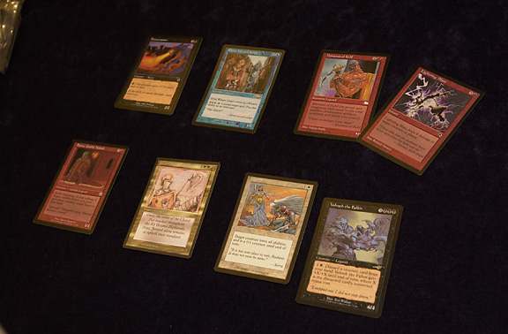
Next, we chose Solomon Draft. This is a two-person draft where players take turn diving eight cards into two piles. The player that doesn't divide gets to draft either pile with the other pile going to the divider. We have played Solomon Draft at every Invitational but one (Barcelona). It is considered by many to be the most skill-testing draft. Logistically, it is hard to run and very time intensive. With a small number of participants and a comfortable play schedule, the Invitational is the only premier event capable of running this format.
The Constructed formats were not as easy to figure out. We started with the following requirements. We wanted one straightforward format. That is a format that is supported and played around the world. This is important as we want to test the players' ability to metagame an existing format. Second, we want a format that tested deckbuilding skills. This obviously needed to be a new format as it had to force the invitees to think in new ways when building a deck. Finally, we were trying to find a way to make a Constructed format that required little preparation. With so many formats, we want to take all the steps we can to minimize how much work the invitees need to prepare.
The preexisting format was chosen by the elimination of all the other choices. Standard was the format of the Pro Tour two weeks later. We didn't want to make the invitees choose whether or not to show the tech they planned to use at the Pro Tour. Standard was out. Likewise, Pro Tour-Tokyo in March would be using Invasion block. Block Constructed was out. The Masters at Pro Tour-New York was Extended. We felt a repeat so soon after was uninteresting.
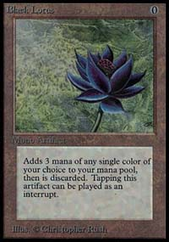
This left us with Type 1. Type 1 proved to be a good choice for a number of reasons. First, while Wizards does support Type 1, there are not very many opportunities at prestigious events to use Type 1. Second, the DCI had restricted and unbanned cards for Type 1 in September. This meant a fresh Type 1 environment. Third, I've learned from past Invitationals that the invitees have a real good time playing Type 1. In fact, the one Constructed format that players seem to play whenever they had some spare time was Type 1. Randy, Henry and I all agreed that Type 1 was perfect.
Next was the new Constructed format. In Kuala Lumpur, we had introduced Block Party. This format let players bring decks from any Magic block (at the time Ice Age through Mercadian Masques). The format had gotten good response from both the invitees and the public. Was there a way to tweak the format to allow innovation? Then it hit us. What if we expanded the rules for deck construction? Instead of choosing a single block, we allow players to make their own block by picking blocks from columns A, B and C.
We spent a few floors of discussion trying to figure out if there was a single dominant deck that would taint the format. But from the time we got from Dali to Pollock we had figured out that numerous archetypes were possible. The new format was called B.Y.O.B. or Bring Your Own Block. One quick aside: I firmly believe that any new format should have a catchy name. I actually spend a great deal of time every year figuring out a cool name for the format. This year's was easy as we were calling it B.Y.O.B. in the museum.
The last format proved easier than we had expected. For about a year, Buehler had been pushing the use of an auction using Pro Tour winning decks. While I had liked the idea, there had never been sixteen Constructed Pro Tour winning decks. But once we added in this year's Worlds along with the two pre-Pro Tour Worlds, we had seventeen decks, a perfect number (since we had wanted one extra deck so the last player bidding had a choice). Weeks later over lunch, Buehler, Skaff Elias, and I hashed out the bidding system. The formats were set.

The Invitations
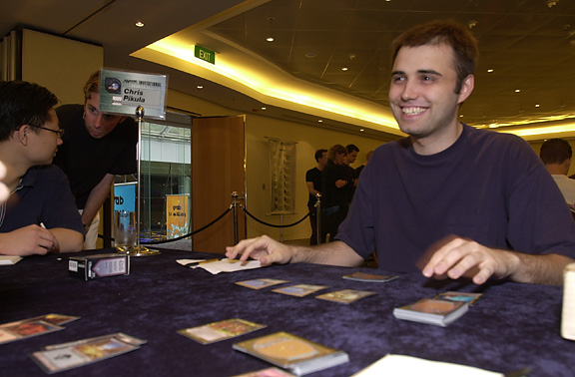
Chris 'The Impossible Dream' Pikula
The Magic Invitational is unique in that it is the only high profile, invitation-only sixteen person tournament. In addition, most of these invitations come from very different criteria. So as the year rolls by, I get to see the roster slowly build up. The first invitee was Chris Pikula because he lived "the impossible dream", defeating Jon Finkel in Kuala Lumpur. Next were the Pro Tour winners: Kyle Rose, Bob Maher, Jr., Trevor Blackwell, Sigurd Eskeland and Jon Finkel. What remained were the players invited on rating and the fan ballot.
This year, we combined the player ballot (in the past handed out at Worlds) and the fan ballot into a single online ballot. Because the ballot was now totally online, I was able to get regular updates on the voting. It was like watching a race, as each day I would check on the frontrunners.
Meanwhile, the players in contention for the ratings invite were all calling me with questions. When was the last day for a tournament to count? This tournament isn't in yet; who can I bug to make sure it gets counted? Are you sure my results from my last tournament are correct? One player, Noah Boeken, even wrote in to explain how the European Championship (which he won) was entered incorrectly (some of the Constructed matches were put in as a Limited matches).
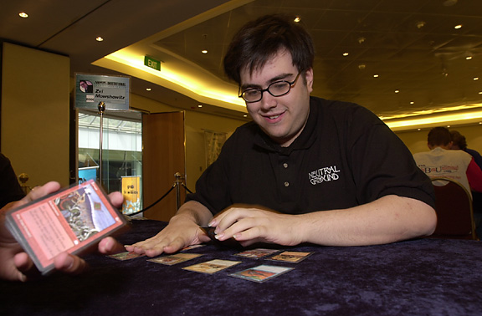
Zvi won the poll last year. This year, he's qualified on his win at Pro Tour-Tokyo
So while I was checking out all the rating info, the fan ballot race continued. Zvi Mowshowitz took an early lead which he kept throughout the poll. In the end, Mowshowitz won by several hundred votes (out of a total of 2600 votes). The next race was between second and third place contenders David Price and Kai Budde. Budde took an early lead, but was ultimately outpaced by Price who beat him by a hundred votes. The real race though was for the fourth slot. Only four players get invited from the fan ballot, so this was the race that really mattered.
Three players were duking it out for fourth: Mike Long, Ben Rubin, and Gary Wise. During the entire two weeks of voting, the three stayed within ten votes of one another. Given the total number of votes, this proved very interesting. First Wise was in the lead. Long then pulled ahead for a while. Then Rubin. Then Long again. And at the wire, Rubin beat Long by a handful of votes.
Meanwhile, in the ratings category, Ryan Fuller called to question the person who had popped ahead of him. I told him that he had one more update before it would become official. If he had problems after the final list was posted, he should let me know. In the end, Fuller won for North America, Gerardo Godinez won for Latin America, Noah Boeken won for Europe and Katsuhiro Mori won for the APAC region.
In previous years, players were informed that they'd been invited when I handed them an invitation at the first Pro Tour of the year. As the event had been moved up considerably we had no time to wait for Pro Tour-New York. Thus, for the first time, the invitations premiered online. I could tell several players were very eager to see the list as numerous players called me the morning of the posting to ask what time the list would go up.

The Substitutions
With the exception of one year (the Invitational in Barcelona), every Invitational has had players decline invitations. The first was Mark Justice who bowed out of the Hong Kong Invitational at the last minute when his brother sprung a surprise wedding on him. His replacement was Mike Long who went on to finish second to Olle Rade. John Yoo and Mark Chalice both turned down an invite to Rio because of work conflicts while Jason Zila simply didn't show up.
Kuala Lumpur had four substitutions, although only two by choice. Svend Geertsen and Tommi Hovi had travel and school conflicts respectively. Randy Buehler was made ineligible when he took his R&D job (although we brought him to the event as a reporter). Casey McCarrel was disqualified when he was suspended by the DCI for six months.

Sydney would be no different. The first person to decline his invitation was Sigurd Eskeland. Eskeland had attended a previous Invitational (in Barcelona) and wanted to attend Sydney but was unable due to school responsibilities. This began the one and only controversy of the event, the invitation of Mike Long. As I explained in the introduction to Long's much belated tournament report from Kuala Lumpur, I was partially responsible for his tardiness, so he was allowed to attend.
Shortly after I informed Long at Pro Tour-New York that he was invited to Sydney, I ran into Kyle Rose who informed me that he was thinking of not attending. He said he was leaning against it but would spend the weekend thinking about it. I talked to some of his friends to get them to encourage him to go. Donnie Gallitz should get special attention for truly giving his all to convince Rose. The day I returned, I got an email from Rose officially declining.
In one weekend, Gary Wise went from the verge of falling out of "first class" (Randy Buehler's name for being qualified for the Master's Series) and was contemplating quitting professional Magic. By the following Monday he had a Pro Tour championship title under his belt and an invitation to Sydney. Suffice it to say that Wise had a good weekend.
The final substitution occurred about six weeks before the event. Katsuhiro Mori, the top rated player from APAC, was a high school student. While he was very eager to attend, Mori was informed by his school that he would fail to graduate if he missed any more days of school. Thus, Mori, through an interpreter, let me know that he had to pass on the Invitational. The invite then fell to the second highest rated player: Yoshikazu Ishii. Ishii responded very quickly that he wanted to attend.

Tournament Preparation
With Pro Tour-Chicago two weeks later, the invitees on average did not spend a great deal of time preparing for the Invitational. Ironically, the opposite is true for me. I have little preparation to do for a Pro Tour, but the Invitational takes weeks of work. To complicate things this year, I had gained a new responsibility at work, I was put in charge of overseeing Creative Text (the new name for names and flavor text).
Normally, Creative Text has two employees (not counting me). One had left six months earlier and the position had not yet been filled. The second employee got burned out (possibly because she was doing the work of both positions) and quit. This put me in the wonderful position of overseeing a staff of zero.
The month before an Invitational is always busy as I have all the Invitational preparation in addition to my normal work. This year, I essentially had an additional full-time job on top of that. Suffice to say, my October was very busy. The reason I bring this up is that in order to get everything done, I had to ask other people to help.
Normally, I personally do everything for the Invitational to make sure that it's all done correctly. I am a bit of a perfectionist and the Invitational is the one event a year I'm responsible for so I take the responsibility very seriously. This year, I was forced to ask for help. This "help" proved to be not as helpful as I would have hoped. (In the writing world, this is called foreshadowing.)
The work was divided up into two parts: preparing for the individual formats and preparing for the logistics of running the tournament. The first part is focused mostly on the Limited formats where I am responsible for choosing the card pool.

Making Card Pools - Duplicate Limited

Wouldn't it be neat if all the cards were easily recognizable yet slightly different?
Let me talk a little about building card pools for Limited formats. The thing that attracted me to writing and then to game design was the ability for creative expression. I love paving new paths and exploring uncharted territory. I put building Limited card pools in this camp, as it's very creative. You have complete control over what does and doesn't matter. Enchantments, for example, could be game-defining or could be non-existent. A 1/1 creature could be worthless or crucial to victory. Mana curves can start wherever you want them to. You are in complete control. R&D essentially does this each year as we redefine the current Limited and Block environments. The only difference in Duplicate Limited is that you can be ever more extreme.
For those that might enjoy trying Duplicate Limited at home (and I heartily recommend trying it), here are a few tips. While you want to change a few things, be careful not to change everything. Part of what makes figuring out a new environment fun is having some basis for comparison. Having too many things change is very disorienting. Normally, I start my Duplicate Limited by making one huge change which I then build around.
In past years, my one change has been things like "make all the cards of a low power level". In the shower one day (I, like other creative types I've talked to, tend to get good ideas in the shower), came up with the idea of changing the mana cost of every card in the card pool. Wouldn't it be neat if all the cards were easily recognizable yet slightly different?
With that in mind, I started looking for cards in two categories. First, good cards that I could cost higher to make them worse and second bad cards I could cheapen to make better. While I was thinking about this, I made an important realization. In order to play this format, I was going to have to come up with a way to create these altered cards. Normally, I just borrow cards from the R&D library for the event. But this format required specially made cards. As I was so busy, I knew that my only choice was to use playtest stickers. These are the stickers we use when testing new cards. We print them up and stick them on old commons. The reason this was important was that it meant I was no longer limited to cards that I could find sixteen copies of in the R&D library. I was free to choose any card from the history of Magic.
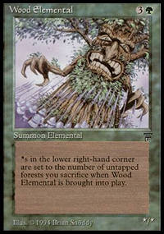
This was a very liberating discovery as finding appropriate cards was proving very difficult. Finding good cards was easy. But, because they required raising the mana cost, the spells were getting very top heavy. (In fact, the whole format ended up very top heavy, which is why the players valued mana acceleration so highly.) Finding bad cards was proving quite challenging. First, a good number of the bad cards we've already revisited and made better in later sets. Other bad cards were too generic. Lowering the mana cost simply made them blatantly good. Since the point of this format was to make the players question the strength of each card, these were no good. Finally, some bad cards were bad no matter how cheap I made them. As an example, I wanted to put Wood Elemental in the card pool. Originally it cost . Even dropping the card to couldn't save it.
Having access to all the cards in Magic allowed me to go back and visit some old friends. I've been playing since alpha, so I was able to look at some cards I hadn't played with in years. From Fork to Oubliette to Jihad to Copy Artifact, I started collecting some old favorites. The other advantage of the older cards was that players didn't have a good power gauge on them.
Another goal I had for the card set was to sneak in as many mechanics as possible. I wrote out a long list of old mechanics and then started adding them in one at a time. Also, one of my trademarks in Duplicate Limited is to weave in many powerful combos to lure the players in different directions. To increase the "combo influence", I chose cards that interacted with multiple other cards. This would lead players down different paths as one card connects to another which connects to another and so on. My design skills came in handy as they allowed me to layer multiple themes into the card pool.
For those that care, here are some of the cycles (meaning one card in each color) that I put into this year's Duplicate Limited: a spellshaper, a creature with a "comes into play" ability, a card with cumulative upkeep, a card which works well against a player using the same color, and an enchant world. I also tried to make sure each color had a mix of good and bad cards that had been altered. Finally, I included artifacts as I purposefully left them out of last year's Duplicate Limited mix.
Once I finished my first pass, I passed the list along to other members of R&D (Randy Buehler, Mike Donais, William Jockusch, Henry Stern and Worth Wollpert.) They all made comments and I tweaked the list. Then we had a playtest with R&D and Organized Play. The running joke is that we always run a playtest (we usually only have time for one) and then overcompensate when adjusting the list. Our playtest showed white and blue to be a bit too strong and red and green to be a bit weak. (Foreshadow #2.)

Making Card Pools - Solomon Draft
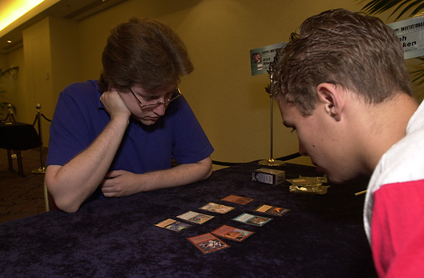
The first Solomon Draft was played at the Hong Kong Invitational. We played it like a normal draft with players opening up actual booster packs. By the time Kuala Lumpur rolled around, we had advanced our Solomon tech considerably. Now all the players drafted from the same pool of cards that appeared in identical pre-made (by me) booster packs. This allowed the audience to compare how different players drafted. Also, it added another level of fun to the tournament as the players could hear everyone else react to the same cards they just opened.
For Kuala Lumpur, I hand picked the overall card pool and then randomized the cards checking to make sure that no goofiness happened in any pack (for example, that the cards split obviously into 7 and 1). All four drafts (the three rounds plus the draft for the finals) had a singular theme. This year I realized that it would be more fun if each draft had its own theme. Part of the skill of the draft would be to deduce the theme and then properly weigh the cards based on the realization of what the draft was doing.
With the release of Invasion, the first theme fell quickly into play - an all multicolor draft. Next, I realized that I wanted a draft where all the cards were Sleight-able, that is all cards with color words in their rules text. The obviously follow-up to that was a draft where the cards were Hack-able, that is all cards with basic land type words in their rules text. Finally, I came up with the idea of having a draft built around legends.
With my four themes in mind, I collected all the cards that fit into the four categories. When cards overlapped in theme, I put them in the draft that had the least amount of cards. I started by building the all multicolor draft. This proved much more difficult than I had anticipated. For starters, I realized that I didn't have enough gold cards to fill out the 96-card draft (96 cards is twelve 8-card boosters). This worked out okay as I knew I needed to add some color fixing to help players play three-plus color decks. I ended up adding a cycle of Cameos and comes-into-play-tapped lands, both from Invasion. In retrospect, I should have probably put in another cycle or two.
Next I made an important discovery about the history of gold cards: the power levels are nowhere near balanced. Black-red, for instance, was brimming over with powerful cards while white-blue was scraping the bottom of the barrel. Luckily, with the addition of the Cameos and tap lands, I was able to yank a few black-red cards. Wanting to knock down the power of black-red, I took the best ones out. This is why cards like Void or Reckless Assault didn't show up. Also, to strengthen white-blue I stole a few good white-blue legends from the legends draft.
The Sleight and Hack drafts proved relatively easy to build. My one flaw in those two drafts was that I failed to include enough artifact destruction to deal with a few powerful artifacts that I had weaved into the draft. Lastly, I built the legends draft. It was obvious when I began that the legends theme was not enough to fill out a 96-card draft. Plus, I realized that legends were more interesting if they were plentiful but not the only creatures. Part of this was to even out the mana curve (as legends tend to have higher mana costs) while part of it was to keep cards like Tsabo Tavoc and Empress Galina from being too powerful.
To fill out the draft, I added another concept. I put in a number of cards which had an allied-color activation. This theme along with the gold legends helped keep the multicolor theme which ran through all the drafts. After my first pass, I was forced to go back and beef up certain colors. You can tell which those are as I added the legendary spellshapers from Prophecy. For a short time, I even contemplated putting multiple copies of certain legends in but then decided that it would upset the players as they would probably all assume that I wouldn't duplicate them in the draft.
The last decision I had was what order I wanted to hold the drafts in. With a showbiz backgorund, I knew the cardinal rule of start strong and end strong. I felt that the multicolor draft was the splashiest and the most fun if it came first. Next, I felt the sleight draft was very tight so I put it as the last round. I felt the Hack draft was the next strongest so I held it for the finals. The legends draft which was the weakest conceptually was stuck in the middle.

Tournament Preparation - Getting Ready
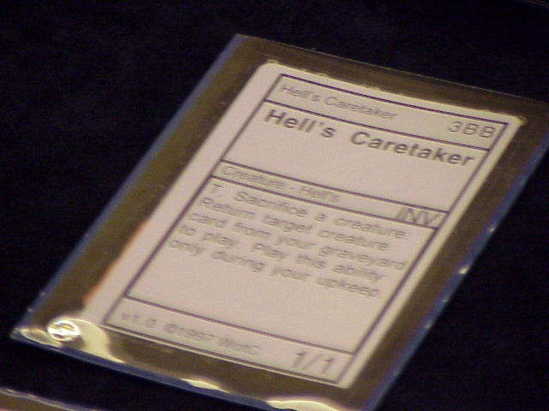
The one final piece complicating my preparation was the fact that my family (my wife, six month old daughter, and myself) were going to Sydney a week early for vacation. This meant that I had a week less than normal to finish everything. As the weekend I was to leave approached, it became obvious that I wasn't going to get it all done. This is the part where I started asking others for help. I put together the sample booster packs for the four drafts and had other R&D people put them together. I personally compiled the Duplicate Limited cards as it involved making stickers, which is not a widely held R&D skill.
The Auction of Champions was the one other event that required advance preparation. Omeed Dariani had managed to get Star City Games to sponsor the auction, meaning they would compile all of the decks (with sleeves) and then mail them to Omeed. The deck boxes to hold the decks had been ordered but had not come in yet when I was about to leave so I left Omeed with the responsibility of getting the decks, labeling them with the names of the Pro Player who won with it, and bringing them to Sydney. Also, due to time, I had not checked each deck, but Omeed assured me that he had checked each one. I asked him to double check the decks before bringing them to the event. (Foreshadow #3.)
In addition, I had to pack up all the supplies I needed. The Invitational is a bit trickier than the average tournament as each format requires different needs. The one advantage of a sixteen-person tournament is that I'm able to carry the supplies personally. I do this because much of the tournament is dependent on items I bring. Losing the Duplicate Limited decks in shipping, for example, would be a disaster.
On top of all my final preparation, I was working with a writer to finish up the first pass of names for Odyssey. So there I was at five in the morning making Duplicate Limited decks while talking over my speaker phone to a very punchy man saying things like, "Can we use the word "necrophiliac"?" (The answer is no.) I haven't pulled an all-nighter (not counting final nights of Pro Tours) for a number of years, but this year's Invitational did require a twenty hour session to finish. I stumbled home at eight in the morning dreary-eyed but done.

The Travel
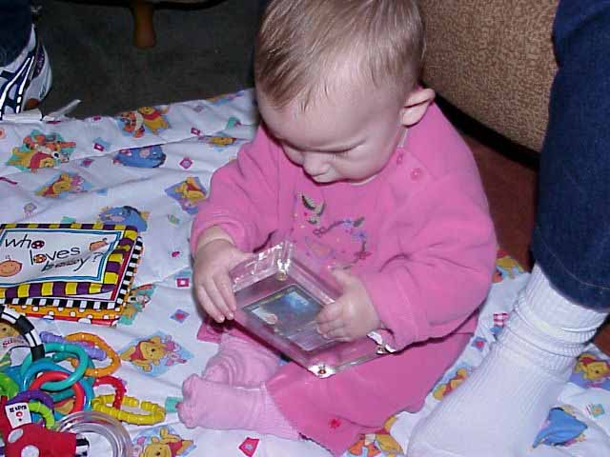
Rachel Rosewater, with the first Meddling Mage ever
While my family never accompanies me to Pro Tours, they always come to the Invitational. We usually take an extra week to make a vacation out of it. In past years, we stayed a week after the event, but due to Thanksgiving, we were forced to come a week early. This proved to be a much better system and will be used in years to come.
I was very excited to go to Sydney. It was one of a handful of cities I had always wanted to visit. One of the big pluses to my job is the ability to travel around the world. The Invitational in particular has taken me to every non-Antarctic continent save one (which we get to this year). The only downside was that it required a fifteen-hour plane ride with my six-month-old daughter. My reluctance was not having to spend that much time with my daughter, as I love being a father and she is a great joy in my life. My concern was the other passengers who would be a little less understanding than me if my daughter decided she didn't like flying. Lora (my wife) and I took every precaution possible to prepare for the flight. Rachel (my daughter) had never flown before, so we were prepared for every conceivable contingency.
Several weeks before we left, I stumbled onto the "flying with an infant" tech. Northwest (the airline we were taking) has bassinets for young children on overseas flights. The catch was that they required sitting at the bulkhead as the bassinet attached to the wall. We were able to reserve the correct seats going but had to make arrangements for coming back in Sydney. Unfortunately, when we got to our connection in San Francisco, we discovered that while they had properly arranged for the bassinet they inconveniently moved us to a seat away from the bulkhead. The trick to getting moved back was to argue with the airline people while holding my daughter.
The flight can best be summed up by the comment we got from our neighbor as we landed. He turned to us as we're gathering our belongings and said, "I must say you have the best behaved child I've ever seen."
Tomorrow: The Invitational!

